Digital literacy

-VITyarthi Report

Name: Palak Roy
Reg. no.: 25BAI11268
Branch: CSE AIML
Year: 2026
course code: CSE0001
Date: 27-03-2026
Overview

Being online is simple in today's environment, but being fully digitally literate is quite another. The goal of this project is to become proficient with the tools that will determine our future rather than merely scrolling and clicking. Consider it a guide to being a competent, safe, and astute creative in a congested online market.
This has been divided into five practical benchmarks:
• Design: We begin by producing a powerful infographic that transforms difficult digital ideas into understandable, graphic narratives.
• Coding: By delving into the Foundations of Coding, we'll reveal the inner workings of the websites and applications we use on a daily basis.
• Communication: We'll become experts in email etiquette, making sure that every communication you write to a professor or potential employer is respected.
• Professionalism: You'll create a digital portfolio, a professional home base that presents the world with your greatest work and abilities.
• Protection: Lastly, we address the internet's wild west by learning how to recognise and prevent cybercrime, which includes identity theft and phishing.

You will be using the internet with a sense of purpose, security, and professional advantage at the end of this project.
Task1: Create a Digital Literacy Awareness Infographic

About:
Being "online" and being "digitally fluent" are very different in a world where we spend hours clicking and scrolling. The goal of this project, "Navigate the Net: Master Your Digital World," is to transform inactive internet users into knowledgeable, capable digital citizens. We simplify the intricacies of the web into an understandable, visual road map for success using a high-impact awareness infographic.
The project starts with a basic Introduction to Digital Literacy, which defines it as the capacity to think critically and assess information in a sea of data rather than merely as a technical skill. After that, we explore a carefully chosen collection of Digital Tools for Students, emphasising how tools like Notion, Canva, and Zotero can transform academic collaboration and productivity.
The infographic offers practical Safe Internet Practices, from understanding Multi-Factor Authentication to identifying sophisticated phishing attempts, to ensure safety in an increasingly complex environment. Lastly, we address the Art of Email Etiquette, teaching students how to write polished emails that will be respected by both future employers and instructors. By the end of this project, participants will be using the internet with a professional edge, a sense of purpose, and security.

Digital awareness infographic:
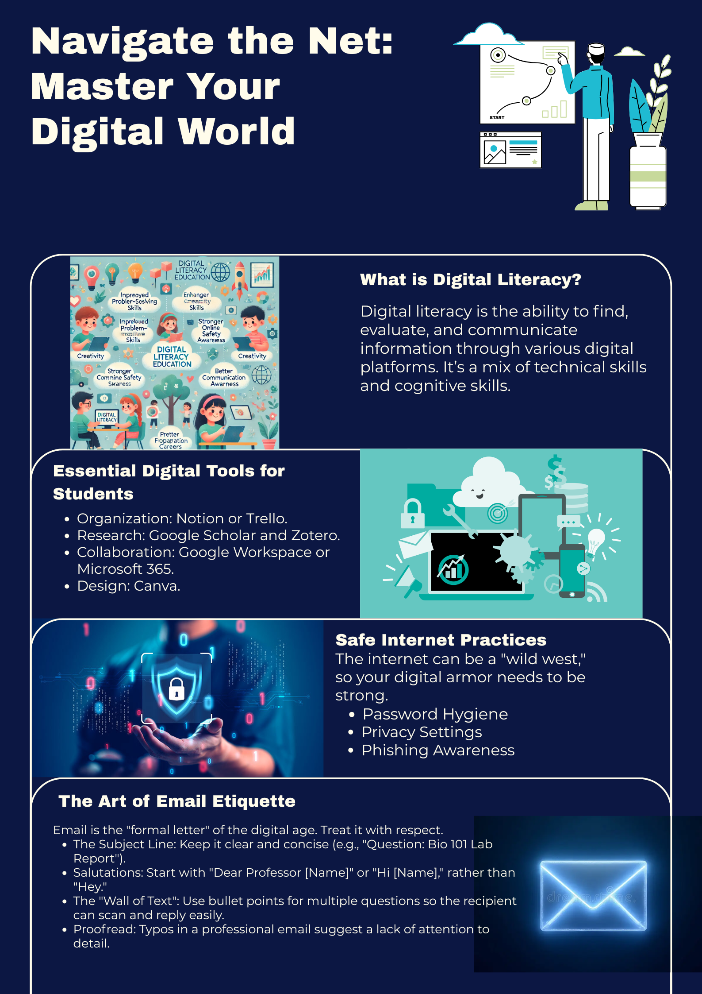

Task2: Build Your Student Digital Portfolio

About:
I intend to strategically use three powerful platforms, Kaggle, GitHub, and LinkedIn, to establish a strong professional presence over the course of the next four years. Each helps me close the gap between academic knowledge and industry readiness and fulfils a specific role in my journey as a student and future professional.
LinkedIn will be my workplace "home base." It is the best platform for personal branding and networking. I want to use it to stay up to date on internships, share project updates, and establish connections with industry experts. I want to create a network that will lead to job opportunities before I even graduate by regularly recording my educational journey there.
GitHub and Kaggle are crucial for technical aspects. I will use GitHub as my "living portfolio" to host my code, contribute to open-source projects, and showcase my expertise in software development. GitHub is the industry standard for version control and collaboration. In the interim, Kaggle will serve as my AI and data science playground. In order to hone my machine-learning abilities, I intend to compete and make use of its extensive datasets. Together, these platforms will present a comprehensive profile of a technically proficient and professionally connected engineer by the end of four years.

LinkedIn:
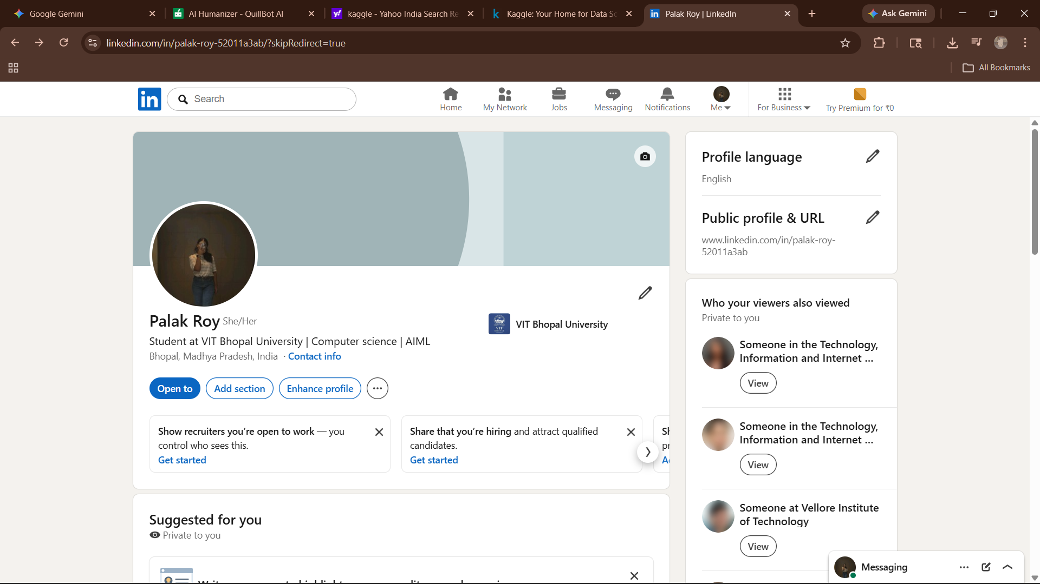

Kaggle:
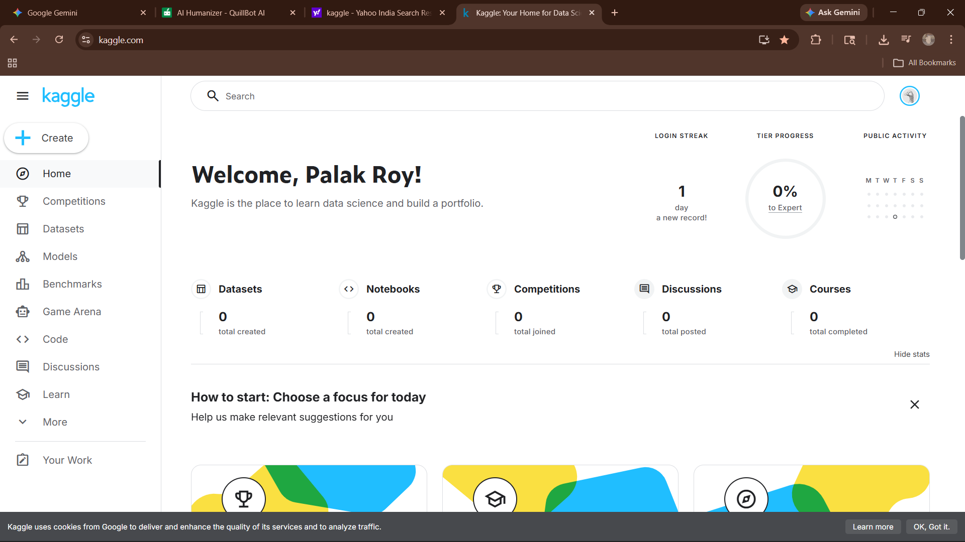

GitHub:

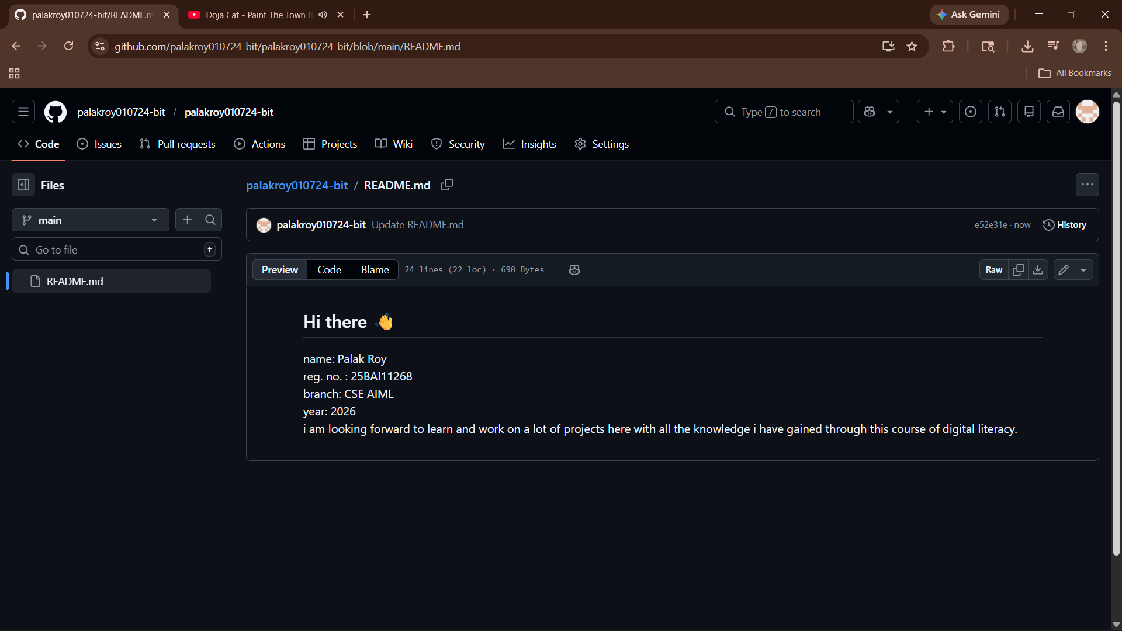

Task3: Explore Coding &Collaboration Platforms
About:
Part-A
HackerRank is an essential link between theoretical knowledge and real-world problem-solving. It offers an organised environment for students to learn Python, going beyond simple syntax to comprehend intricate algorithms and data structures. You may hone the logical rigour needed for technical interviews by practicing loops, functional programming, and string manipulation on the platform. Over time, HackerRank creates a verified portfolio of competitive rankings and skill certifications that attract employers, making sure you are ready for the demanding setting of live coding examinations.
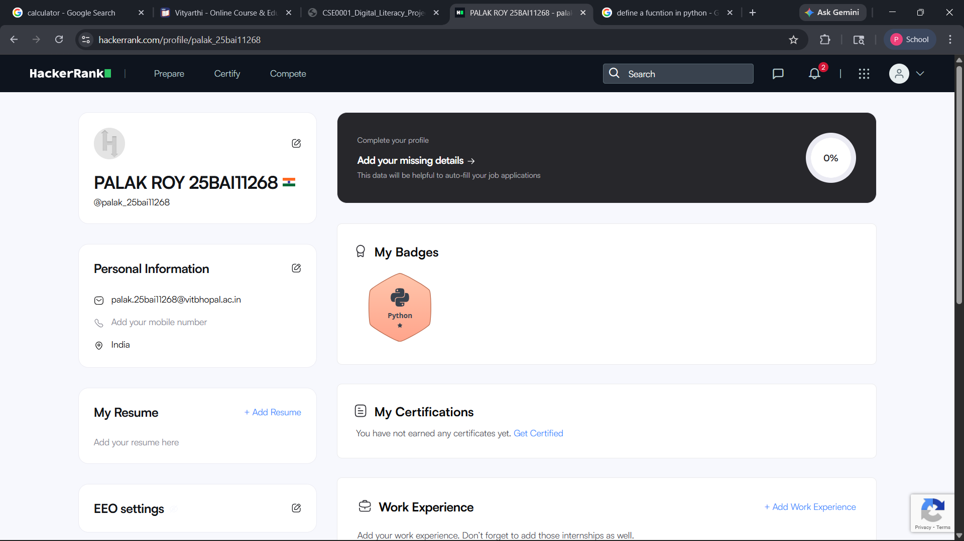

Part-B
Google Forms is an extremely valuable asset when it comes to streamlining data collection and user participation. Utilising this form to survey a digital literacy awareness test can aid in gauging public opinion on issues such as online ethics and security. Such capabilities are valuable when processing a large database, carrying out primary research and even receiving feedback from peers. Linking spreadsheets and obtaining instant summary results automates the data processing stage and enables one to undertake academic tasks in a data-informed way. Learning these processes enables one to close the space between recognising a need in society and applying a logical, measured solution.

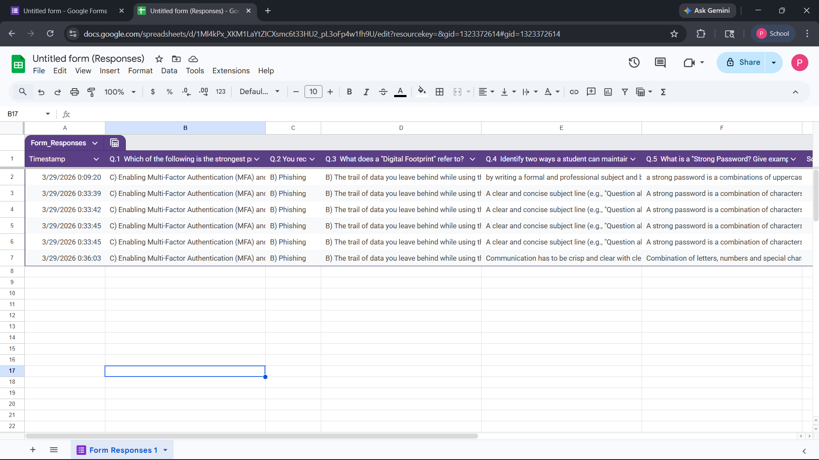
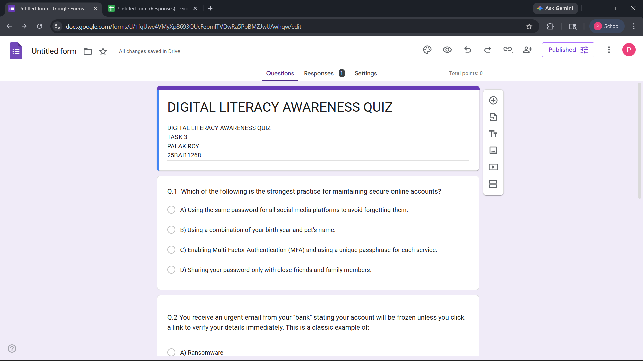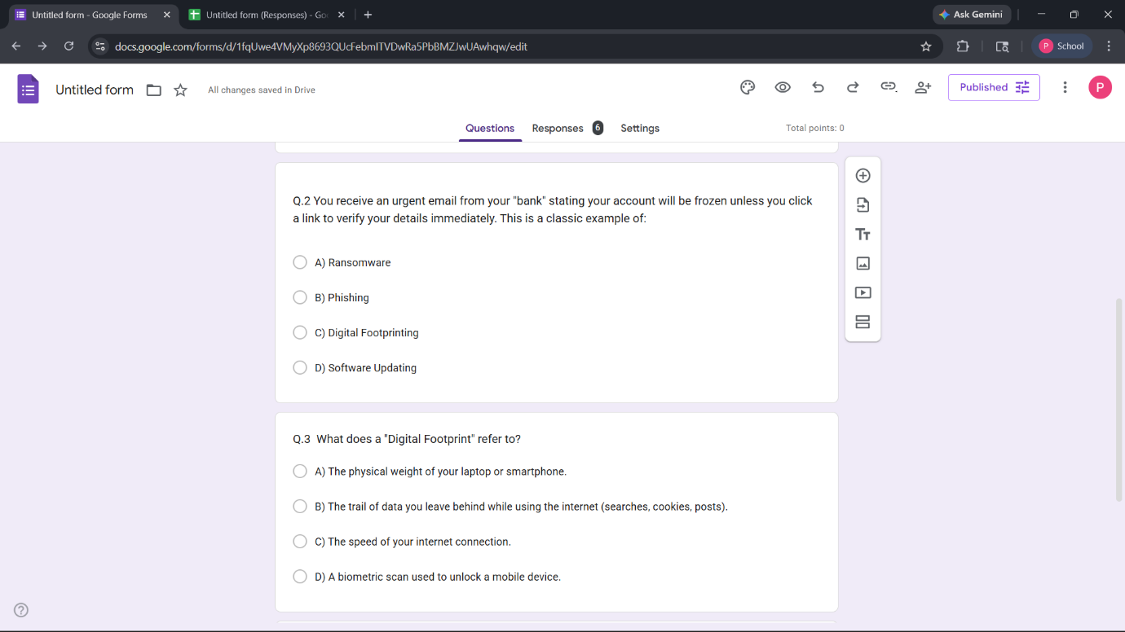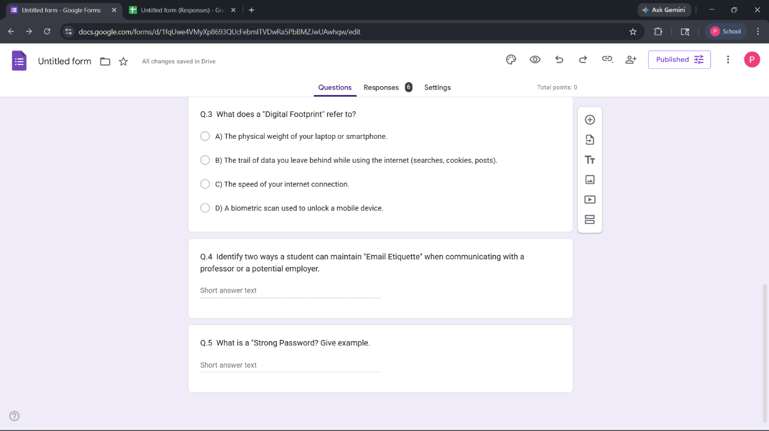
Task4: Draft a Professional Email & Etiquette Guide
Part B: Create a Social Media Do's and Don'ts checklist
Do’s:
- Check your privacy settings periodically so you know precisely who is seeing your posts.
- Shout out to some achievements like having Certifications for Python, having good GitHub profiles, etc.
- Connect with the industry professionals and alumni from your domain like AIML and data science etc. And get the latest trends in the field.
- Read and check a source before posting it to avoid being a digital information misinformer.
- Upload a professional picture for your profile on sites like LinkedIn so you create a good first impression.
- Tag other students in the sensitive pictures that you upload without their prior consent.

Don’ts’:
- Do not post sensitive and confidential information such as your Student ID number, home address, private project keys, etc.

- Get involved with arguments and flame wars that negatively portray your emotional intelligence.
- Do not post pictures and videos that involve criminal activities or violate the academic integrity code of your institution.
- Talk ill about your professors or boss as this will be perceived by recruiters as not being able to handle professional situations.

One situation where poor digital communication caused a real problem, and what could have been done differently.
One widespread and detrimental example of poor digital communication occurs when a professional or student complains through "Reply All." One famous hypothetical is a student who sends an angry e-mail to their professor about a grade, and includes everyone in the department as an addressee. Rather than being a private, helpful discussion about the problem, the e-mail can be read as an attack on the professor and a detriment to the student's image.

This situation could have been averted through pause and reflection. The student should have checked his recipient list before sending and should have tried to avoid sending an angry response. A better approach would have been to ask for a quick virtual meeting or for a separate e-mail chain, using a subject line like "Discussion about xyz project Feedback" to preserve confidentiality and keep the e-mail contained.
Task4: Cybercrime Awareness Case Study & Prevention Guide

write 100–150 words on: what surprised you most while researching this topic, and one habit you will personally change as a result.
The most eye-opening thing about researching digital security, and the Indian digital ecosystem more specifically, is how psychologically nuanced the UPI 'Request Money' scams are. The concept that something designed for ease of payment can be subverted to 'ask' a person to send money instead of receiving it seems bizarre. Incredibly, to circumvent a student's logical processing of how a PIN should only be used to "send money" scams employ a technique that forces a student to authorize their own loss by stating a scholarship or reimbursement is "waiting to be claimed".

Based on the research conducted, one good practice to implement immediately is 'Metadata and Secret Scrubbing' prior to every code commit. While I often look at the functionality of a Python or Go script, the simplest way to leave sensitive information such as an API key, a personal email address or an ID number in a script can be either in a comment or a config file. Therefore, moving forward, the best practice I'll adopt is either to use a 'secrets-scanning' tool or simply a manually executed checklist before I push to either GitHub or Kaggle.

Conclusion

The accomplishment of these five major tasks has been the ultimate bridge towards the fundamental aspects of dealing with the current online world. Moving through the creative aspect of content production, the professional dimension of branding and the technical aspect of security has indeed covered the spectrum from merely navigating the internet to having expertise on it.

Both the Digital Literacy Awareness Infographic and the Student Digital Portfolio helped enhance our sense of visual communication and personal branding to show that the information not only being received but is also produced with intention. On the same time, the Coding and Collaboration Platforms allowed us gain exposure to a more advanced process while the Professional Email and Etiquette Guide allowed us improve on the soft skill needed for our digital citizenship.

Lastly, the Cybercrime Awareness Case Study served as an eye-opener to demonstrate that technology is meaningless without vigilance and security is always necessary no matter how advance our technical skill may be. All in all, this project allows a good balance in the mastery of the cyber-world through efficiency, artistry and security. Moving on, what we have achieved will remain as our permanent tool for professional improvement.

References: LLMs, Wikipedia, internet, cybercrime.gov.in

